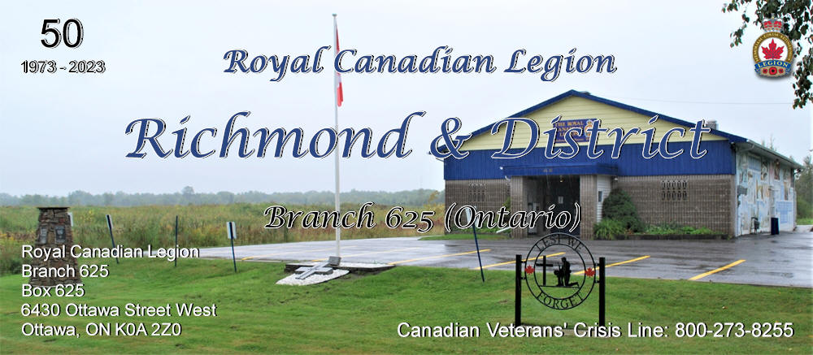
Branch Executive for 2025
PRESIDENT: | Brian Goss | br625president@gmail.com | 613-838-4269
PAST PRESIDENT: | Wendy Ryan | wryan1955@hotmail.com | 613-838-9696
1ST VICE: | Iain Clogg | vicepresidentrclbr625@gmail.com | 613-986-8631
TREASURER: | Pat McGrath | treasurerrcl625@gmail.com | 613-838-2652
SECRETARY: | PatMcGrath | secretaryrcl625@gmail.com | 613-838-2652
SGT-AT-ARMS:
VETERANS SERVICES: | Iain Clogg | vsorclbr625@gmail.com | 613-986-8631
SENIORS: | Pat McGrath | seniorsrcl625@gmail.com | 613-838-2652
POPPY: |  | poppyrcl625@gmail.com
Poppy Trust Chair: | Wendy Ryan | poppyrcl625@gmail.com | 613-838-9696
MEMBERSHIP: | Boyd Dulmage | membership625@gmail.com | 613-838-5055
PUBLIC RELATIONS:
BYLAWS/RESOLUTIONS: | Wendy Ryan | br625richmond@gmail.com | 613-838-9696
SPORTS OFFICER: |  | sportsrcl625@gmail.com
HONOURS & AWARDS: | Wendy Ryan | wryan1955@hotmail.com | 613-838-9696
YOUTH & EDUCATION: |  | youthrcl625@gmail.com

